NEWS TRACKER APPLICATION

SOLUTION ARCHITECTURE

**Team Members:**

**DEEPAK S**

**GOMATHI SANKAR M**

**HARISHANKAR B**

**KAMESH E**

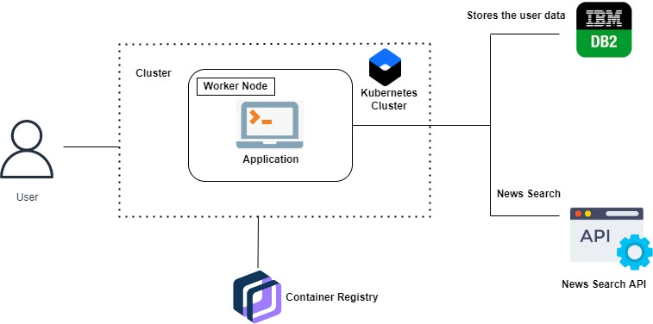

* The user interacts with the application.
* Registers by giving the details.
* Integrate the application with news APIs and store the data in the database.
* The database will have all the details and the user can search the news by using a search bar.
* APIs is used for searching the news faster compare to website.